**Additional information (on algorithms, data / control flow, etc) as applicable**

This is the user flow for a farmer who uses the bot

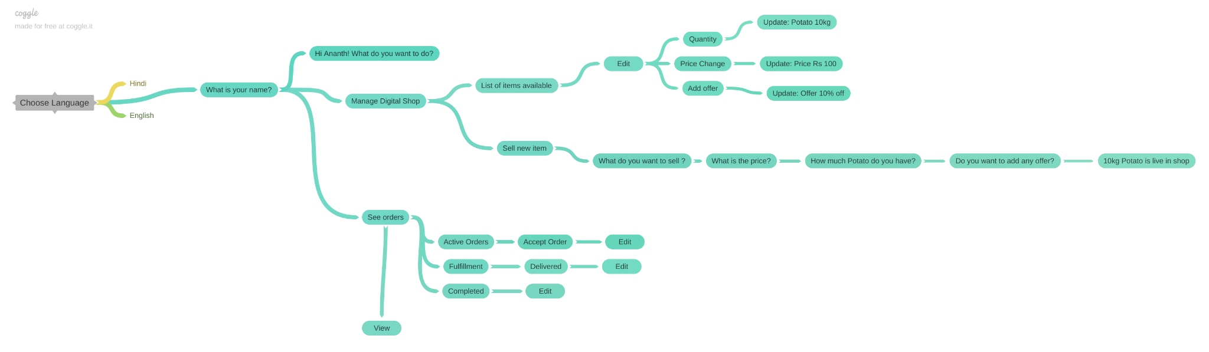

Above flow can be easily viewed in <https://coggle.it/diagram/YsBsN7ndxQl8x-7Z/t/choose-language/7f61eb213cea5e0885842652aff1515c063bfbd44c61602d015a7095140b121a>